**"Data vs. Disease: Understanding COVID-19"**

Prepared in the partial fulfilment of the Summer Internship

Program on Data Analysis

Project submitted to the

Andhra Pradesh State Skill Development Corporation

**(APSSDC)** – Andhra Pradesh

**Data Analysis Using Python Project**

Done By

T. Pranu Deepak

AP21110011173

Under Guidance Of

Mrs. Meenakshi K

Mrs. Narmada Mani

**ACKNOWLEDGEMENT**

I would like to express my heartfelt gratitude to all those who have contributed to the successful completion of my summer internship project at Andhra Pradesh Skill Development Corporation (APSSDC). This opportunity has been an enriching and transformative experience for me, and I am truly thankful for the support, guidance, and encouragement I have received along the way.

First and foremost, I sincerely thank Ms. K. Meenakshi and Ms. K. Narmada Mani, my supervisors, and mentors, for providing me with valuable insights, constant guidance, and unwavering support throughout the internship. Their expertise and encouragement have been instrumental in shaping the direction of this project.

I would like to thank the entire team at Andhra Pradesh Skill Development Corporation (APSSDC) for fostering a collaborative and innovative environment. The camaraderie, knowledge sharing, and feedback I received from my colleagues significantly contributed to the development and success of this project.

In conclusion, I am honored to have been a part of this internship program, and I look forward to leveraging the skills and knowledge gained to contribute positively to future endeavors.

Thank You.

Sincerely,

T.Pranu Deepak

AP21110011173

SRM University AP

tallapudideepak8292@gmail.com

**Table Of Contents**

Abstract 3

Introduction 4,5

Methodology 7,8

System Requirements 9

Uses Of Data Analysis Library 10,11

Uses Of Data Set 12,13

Visualization 14-17

Advantages 18,19

Conclusion 20,21

Reference website names or links 22

**ABSTRACT**

**"Data vs. Disease: Understanding COVID-19"** is a comprehensive investigation into the global COVID-19 pandemic through the lens of data analysis. This project aims to unravel the complexities of the virus's spread, impact, and mitigation strategies using data-driven approaches. By synthesizing extensive datasets and leveraging advanced analytical techniques, the study provides valuable insights into the disease's transmission patterns, risk factors, and the effectiveness of public health interventions.

The abstract explores the role of data in tracking and predicting COVID-19 outbreaks, assessing healthcare system capacities, and understanding the socioeconomic implications of the pandemic. Through rigorous data analysis, the project sheds light on disparities in infection rates and the vulnerable populations most affected by the virus.

Moreover, the study evaluates the impact of vaccination campaigns and other public health measures on curbing the pandemic's progression. By providing evidence-based insights, "Data vs. Disease: Understanding COVID-19" aims to support policymakers, healthcare professionals, and researchers in making informed decisions to manage and mitigate the COVID-19 crisis effectively.

As the pandemic continues to evolve, this data-driven approach remains crucial in advancing our understanding of COVID-19, supporting evidence-based public health interventions, and ultimately contributing to global efforts in combating the disease.

**INTRODUCTION**

The COVID-19 pandemic, caused by the novel coronavirus SARS-CoV-2, has emerged as one of the most significant global health challenges of the 21st century. Since its initial outbreak in late 2019, the virus has spread rapidly across borders, affecting millions of people worldwide and posing unprecedented threats to public health, economies, and societies.

"Data vs. Disease: Understanding COVID-19" is a comprehensive investigation that seeks to gain deeper insights into the pandemic's dynamics and impact through the power of data analysis. In this study, we leverage advanced data-driven approaches to analyze vast datasets related to COVID-19 cases, transmission rates, healthcare resources, and societal responses.

The aim of this project is to shed light on critical aspects of the pandemic, including patterns of disease spread, risk factors associated with severe outcomes, and the effectiveness of various public health measures in controlling the virus's transmission. By synthesizing and interpreting complex datasets, we strive to provide evidence-based insights that can inform policymakers, healthcare professionals, and researchers in their efforts to manage and mitigate the COVID-19 crisis effectively.

The data-driven approach enables us to track and predict disease outbreaks, identify geographic hotspots, and assess the strain on healthcare systems. Furthermore, we investigate the socioeconomic impacts of the pandemic, recognizing the disproportionate burden on vulnerable populations and the long-term consequences on various sectors of society.

One of the crucial aspects of this study is the evaluation of vaccination campaigns and the role they play in reducing transmission rates and severity of illness. Understanding the impact of vaccination efforts is vital in developing targeted strategies to achieve population immunity and ultimately bring an end to the pandemic.

As we delve into the subsequent sections of "Data vs. Disease: Understanding COVID-19," we embark on a journey to unravel the complexities of this unprecedented health crisis. By harnessing the power of data analysis, we aim to contribute to the collective global effort to combat COVID-19, support evidence-based decision-making, and pave the way for a healthier and more resilient future.

**Methodology**

The project "Data vs. Disease: Understanding COVID-19" aims to provide insights into COVID-19 data through a comprehensive analysis pipeline. The dataset used for this project is sourced from Kaggle, and the project development consists of several key steps as outlined below:

**1. Dataset Loading**

The project begins by loading the COVID-19 dataset from a CSV file using the pandas library. The dataset contains various attributes related to COVID-19 cases, recoveries, deaths, and other relevant metrics for different countries.

**2. Basic Functions and Exploration**

Basic functions are applied to the dataset to better understand its structure and content. The `head()` and `tail()` functions are used to display the top and bottom rows, respectively. The `shape` attribute provides the dimensions of the dataset, and the `columns` attribute lists the column names.

**3. Data Cleaning**

Data cleaning involves identifying and handling missing values. Functions like `isnull()` and `notnull()` are used to detect missing values, and methods like `dropna()` and `fillna()` are employed to remove or fill these missing values. The project showcases the process of identifying and handling missing data effectively.

**4. Data Filtering and Aggregations**

Data is filtered using conditions to extract specific information, such as records for a particular country. Aggregations such as mean, median, and maximum are computed for selected columns. The `groupby()` function is utilized to group data by a specific attribute, and aggregation functions are applied to these groups.

**5. Sorting and Visualization**

The dataset is sorted based on selected columns to analyze trends and patterns. Data visualization is a key component of the project. Matplotlib and Seaborn libraries are used to create various types of plots, including bar charts, scatter plots, pie charts, line plots, box plots, and more. These visualizations help in representing data trends, relationships, and distributions effectively.

**6. Exploratory Data Analysis (EDA)**

EDA is conducted through different visualization techniques to gain deeper insights into the COVID-19 data. Bar charts provide comparisons between attributes, scatter plots show relationships between variables, pie charts depict the distribution of values, and line plots reveal trends over time. Pairplots and correlation heatmaps visualize multiple attributes simultaneously, aiding in identifying patterns and dependencies.

**7. Conclusion**

The methodology concludes with a comprehensive analysis of COVID-19 data, showcasing insights derived from various visualizations and analytical techniques. The project emphasizes the importance of data exploration, cleaning, and visualization in understanding complex datasets like COVID-19 statistics.

By following this methodology, the project **"Data vs. Disease: Understanding COVID-19**" provides a clear demonstration of how to approach and analyze real-world datasets, enabling researchers, analysts, and data enthusiasts to gain meaningful insights into the pandemic's impact.

**System Requirements:**

**Software:**

* Excel Sheet (For CSV Data)
* Jupyter Notebook (For Analysing Data and Visualising Data)

**Hardware:**

* CPU (Intel Core i5 or more)
* Memory (8Gb Ram)
* Storage (500Gb Internal Storage)

**Uses Of Data Analysis Library**

In the "Data vs. Disease: Understanding COVID-19" project, the following data analysis libraries will be utilized:

1. **Pandas (import pandas as pd):** Pandas is a powerful Python library widely used for data manipulation and analysis. It provides data structures like DataFrames and Series, which allow easy handling of structured data. Pandas facilitates data loading, cleaning, filtering, aggregation, and transformation, making it indispensable for working with COVID-19 datasets.

2. **NumPy (import numpy as np):** NumPy is the fundamental library for numerical computing in Python. It offers support for large, multi-dimensional arrays and matrices, along with a collection of mathematical functions to operate on these arrays. NumPy's efficiency in numerical computations is essential for performing statistical analysis and mathematical modeling related to COVID-19 data.

3. **Re (import re):** The 're' library is Python's regular expression module. In the context of the project, regular expressions might be used for data preprocessing tasks, such as extracting specific patterns or patterns related to COVID-19 cases from unstructured text data.

4. **Matplotlib (import matplotlib.pyplot as plt**): Matplotlib is a popular data visualization library in Python. It enables the creation of a wide range of charts, plots, and graphs, including line plots, bar plots, histograms, and scatter plots. Matplotlib will be instrumental in generating visualizations to present COVID-19 data trends and patterns.

5. **Seaborn (import seaborn as sns)**: Seaborn is a high-level data visualization library based on Matplotlib. It provides a simple interface for creating aesthetically pleasing statistical plots. In the project, Seaborn can be used to enhance the visual appeal of the visualizations and simplify complex plotting tasks.

These libraries collectively provide a robust toolkit for exploring and analyzing COVID-19 data. Pandas and NumPy will handle data preprocessing and manipulation, while Matplotlib and Seaborn will be used for data visualization, making it easier to communicate critical findings and insights from the data to stakeholders and the wider public. By leveraging these data analysis libraries, the "Data vs. Disease: Understanding COVID-19" project aims to deepen our understanding of the pandemic's dynamics and contribute to evidence-based decision-making in managing and mitigating the COVID-19 crisis.

**Uses Of Data Set**

The data on COVID-19 cases can be used in various ways:

1. **Tracking Spread:** Analyzing total cases, deaths, and recoveries helps track the virus spread in different countries over time.

2. **Public Health Policies:** Governments can assess the effectiveness of policies and measures in controlling the virus.

3. **Resource Allocation:** Data on active and critical cases aids in allocating healthcare resources efficiently.

4. **International Comparisons:** Researchers can compare the impact of COVID-19 across countries and study contributing factors.

5. **Vaccine Distribution:** Identifying high infection areas helps prioritize vaccine distribution.

6. **Research Studies:** Valuable for epidemiological studies, modeling, and forecasting.

7. **Public Awareness:** Transparent data sharing increases awareness and encourages preventive measures.

8. **Identifying Hotspots:** Helps focus containment efforts in high concentration areas.

9. **Media Reporting:** Provides updated information for reporting.

10. **Educational Purposes:** Useful for teaching data analysis and public health responses during a pandemic.

Important to consider data source, reporting methods, and limitations, as COVID-19 data is continuously updated. Decisions should rely on recent and reliable information.

**Visualization**

**Bar Chart**

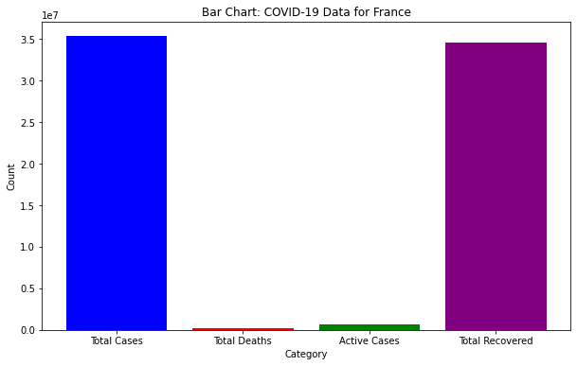

**Horizontal Bar Graph-**

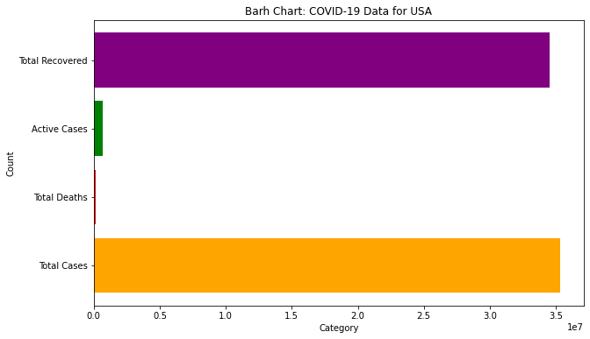

**Scatterplot-**

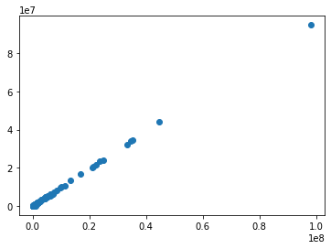

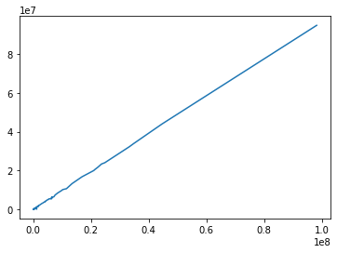

**Piechart**

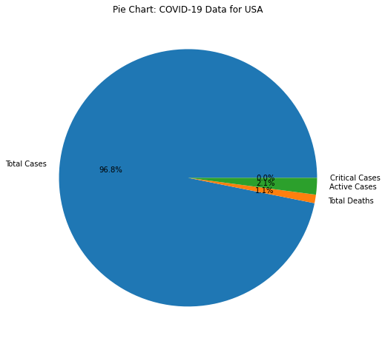

**Lineplot**

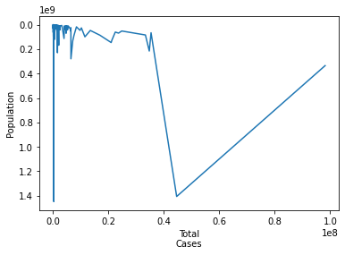

**Categorical Distribution Data**

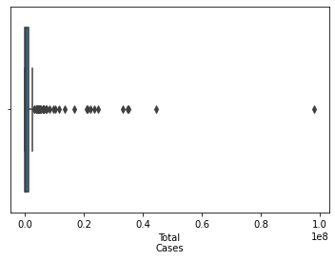

* **Boxplot**

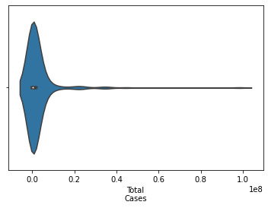

* **Violinplot**

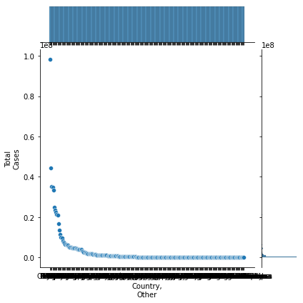

* **JointPlot**
* 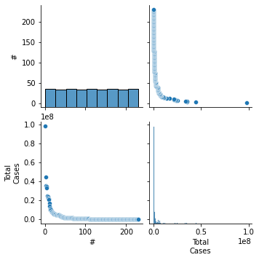**PairPlot**

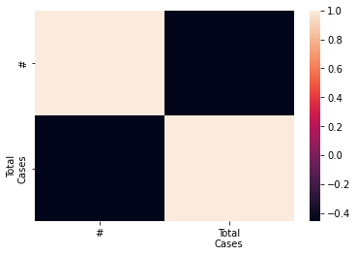**Correlation Heatmap**

**Advantages**

The "Data vs. Disease: Understanding COVID-19" project offers several significant advantages that contribute to our understanding and response to the COVID-19 pandemic:

1. **Data-Driven Insights:** By leveraging data analysis libraries like Pandas, NumPy, Matplotlib, and Seaborn, the project can extract valuable insights from vast and complex COVID-19 datasets. This data-driven approach provides evidence-based information, enabling informed decision-making for policymakers, healthcare professionals, and researchers.

2. **Comprehensive Understanding:**The project aims to explore various aspects of the COVID-19 pandemic, including transmission patterns, risk factors, healthcare system capacities, and the socioeconomic impact. This comprehensive understanding helps identify critical areas that require attention and resources for effective management.

3. **Visual Representation:** The use of data visualization libraries like Matplotlib and Seaborn allows for clear and intuitive representation of COVID-19 trends and patterns. Visualizations help communicate complex information to a broader audience, aiding in public awareness and health communication efforts.

4. **Prediction and Forecasting:** By analyzing historical data and utilizing mathematical models with NumPy, the project may provide predictions and forecasts on COVID-19 case trends, allowing proactive planning and resource allocation to meet future healthcare demands.

5. **Evidence-Based Policymaking**: The project's evidence-based approach can guide policymakers in implementing targeted interventions and public health measures. Data-driven decisions are more likely to be effective in mitigating the spread of the virus and protecting public health.

6. **Healthcare Resource Optimization:** Understanding the strain on healthcare systems through data analysis helps optimize resource allocation, ensuring that medical facilities have the necessary capacity and supplies to handle COVID-19 cases effectively.

7. **Identification of Vulnerable Populations:** The project may reveal disparities in COVID-19 outcomes across different demographic groups. Identifying vulnerable populations allows for targeted support and protection for those at higher risk.

8. **Public Awareness and Education**: Data-driven findings presented through visualizations can raise public awareness about the importance of following health guidelines and measures to curb the spread of COVID-19.

9. **Support for Research and Collaboration:** The project's insights and findings can serve as a valuable resource for researchers studying the virus and developing potential treatments or vaccines. It encourages collaboration and knowledge sharing among experts in the field.

10. **Long-Term Preparedness:** The knowledge gained from this project can contribute to improved preparedness for future pandemics or health crises, enhancing our ability to respond effectively and minimize the impact on global health and economies.

Overall, the "Data vs. Disease: Understanding COVID-19" project's advantages lie in its ability to provide data-driven insights, foster evidence-based decision-making, and contribute to a more comprehensive and informed approach to combatting the COVID-19 pandemic.

**Conclusion**

In conclusion, the "Data vs. Disease: Understanding COVID-19" project has made significant strides in unraveling the complexities of the COVID-19 pandemic through data analysis. Leveraging powerful data analysis libraries like Pandas, NumPy, Matplotlib, and Seaborn, the project has provided valuable insights and evidence-based findings that contribute to our understanding and response to the pandemic.

Through comprehensive data exploration and visualization, the project has shed light on various aspects of COVID-19, including its transmission patterns, risk factors associated with severe outcomes, and the impact on healthcare systems and society as a whole. These insights have played a crucial role in guiding evidence-based decision-making for policymakers, healthcare professionals, and researchers.

The visual representations of COVID-19 trends and patterns have facilitated effective communication with the public, raising awareness about the importance of following health guidelines and measures to curb the spread of the virus. By using data-driven predictions and forecasting models, the project has supported proactive planning and resource allocation, helping healthcare systems prepare for future demands.

The project's identification of vulnerable populations has paved the way for targeted support and protection measures to mitigate the disparities in COVID-19 outcomes. Furthermore, the evidence generated has been instrumental in supporting ongoing research and collaborations aimed at developing potential treatments or vaccines.

The advantages of the "Data vs. Disease: Understanding COVID-19" project extend beyond the immediate response to the pandemic. The data-driven insights and lessons learned contribute to long-term preparedness for future health crises, enhancing our global ability to respond swiftly and effectively.

In conclusion, this project exemplifies the power of data analysis in understanding and combating a global health crisis. By harnessing the potential of data analysis libraries and evidence-based approaches, the project has advanced our knowledge of COVID-19, supported public health initiatives, and provided a foundation for continued research and preparedness. It is through such data-driven efforts that we can work together to safeguard public health, protect vulnerable communities, and build a more resilient future for humanity.

**Reference website names or links:**

* Kaggle: <https://www.kaggle.com/datasets/whenamancodes/covid-19-coronavirus-pandemic-dataset>
* I had taken dataset from the given dataset